**Data Structures and Algorithms**

Exercise 2: E-commerce Platform Search Function

**Understanding Asymptotic Notation:**

* **Big – O** notation provides a way to analyse the time or space taken by an algorithm. It describes the asymptotic behaviour or the order of growth of time or space taken by the algorithm. It provides an upper limit on the time or space taken.

If f(n) is a function and g(n) is another function then we can say

* + f(n) is O(g(n)) if there exists constants c > 0 and n1 > 0 such that
  + f(n) <= c*g(n) for all n >= n1

The Big-O notation helps in comparing the time complexity or space complexity of different algorithms. It can be used to measure the efficiency of an algorithm. It provides a way to describe how the runtime or space requirements of an algorithm grow with increase in input size.

* Best Case – The best case for a searching algorithm is when it finds the required element in its first comparison. For linear search it occurs when the required element is at the first index and for binary search it occurs when the required element is at the middle of the array.
* Average Case – The average case for a searching algorithm is when it has to compare half of the elements to find the required element.
* Worst Case – The worst case for Linear search is when it has to check all the elements and for Binary Search it is when the element is found by reducing the rage to 0 which is its last iteration.

**Setup**

) Product.java

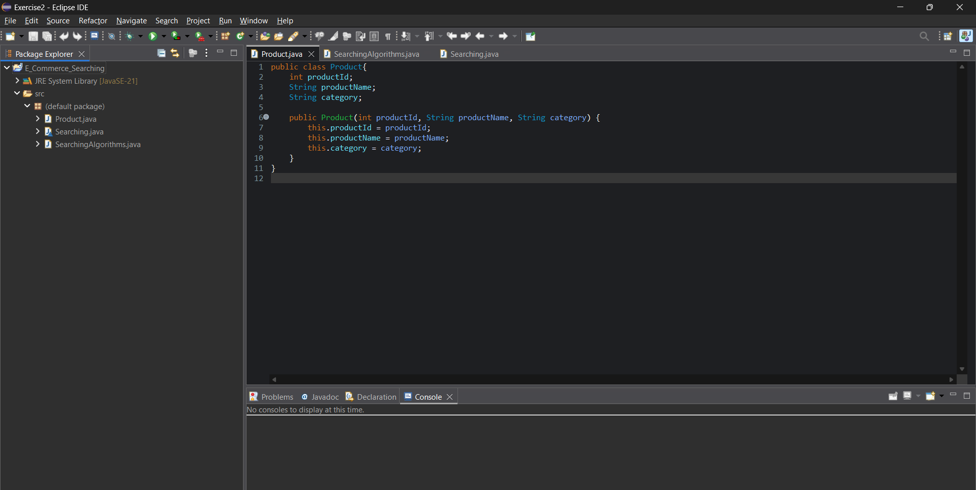

**Implementation**

) SearchingAlgorithms.java

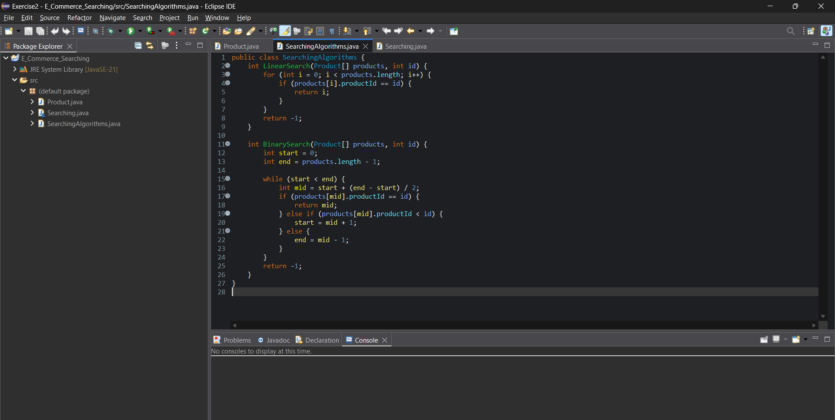

) Searching.java

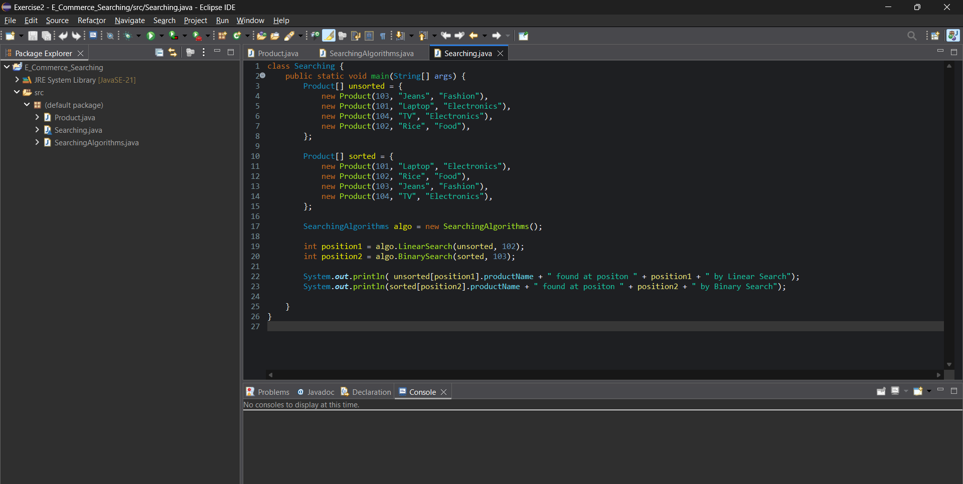

**Output**

) Terminal

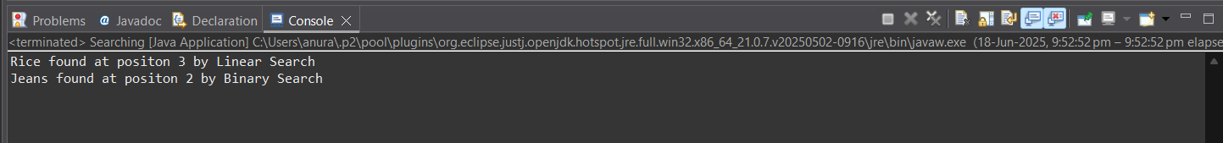

**Analysis**

1. Linear Search has a linear time complexity. Its runtime increases with increase in input size. It can be represented as **O(n)**. It works better with small datasets but does not perform in case of large datasets.
2. Binary Search has a logarithmic time complexity. It can be represented as **O (log n).** It may not work faster with small datasets but works much better with larger datasets, compared to linear search.

For the searching purpose in an e-commerce platform, using **Binary Search** will be the better option as there may be a large number of products from which the desired product has to be searched. Therefore, Binary Search is suitable for our platform.